HANG IN THERE!

BUILDING BRIDGES: FAMILY SCIENCE NIGHT 2009

OBJECTIVES:
- Students build a model of a bridge and test the amount of weight it will support.
- Students will be able to identify different types of bridges: suspension, arch, girder, truss, cantilever, cable-stayed and moveable.
- Students will learn materials can be positioned in specific patterns to form a stronger structure.
- Bridges are structures which carry people and vehicles across natural or man-made obstacles. There are many types of bridges. Based on the length of the barrier to be crossed, the amount and type of traffic as well as forces of nature (wind, tide, flood) different materials and shapes of bridges are used.
- In this lesson your team will learn to recognize several different types of bridges and design and construct a model.
MICHIGAN GRADE LEVEL EXPECTATIONS:
P.FM.E.3 Force – A force is either a push or a pull. The motion of objects can be changed by forces. The size of the change is related to the size of the force. The change is also related to the weight (mass) of the object on which the force is being exerted. When an object does not move in response to a force, it is because another force is being applied by the environment.
P.FM.00.31 Demonstrate pushes and pulls on objects that can move.
P.FM.00.32 Observe that objects initially at rest will move in the direction of the push or pull.
P.FM.00.33 Observe how pushes and pulls can change the speed or direction of moving objects.
P.FM.00.34 Observe how shape (for example: cone, cylinder, sphere) and mass of an object can affect motion.
NATIONAL SCIENCE STANDARDS:
Physical Science:
- Properties And Changes Of Properties In Matter (5-8)
- Motions And Forces (5-8)
- Structure And Properties Of Matter (9-12)
- Motions And Forces (9-12)
VOCABULARY:
- arch bridge
- beam bridge
- cable-stayed bridge
- suspension bridge
STEPS TO FOLLOW:
- Introduction to bridges.
Bridges are structures used by people and vehicles to make crossing areas easier in travel. Engineers build bridges over rivers, lakes, ravines, canyons, railroads, and highways.
The type of bridge used depends on various features of the obstacle. The main feature that controls the bridge type is the size of the obstacle. How far is it from one side to the other?
Bridges must be built strong enough to safely support their own weight as well as the weight of the people and vehicles that pass over it. The bridge must also withstand natural occurrences that include weathering, earthquakes, strong winds, and freezing and thawing.

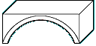
Arch bridge | 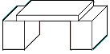
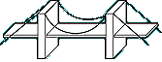 | Beam bridge
Suspension bridge | 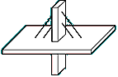
 | Cable-stayed bridge

A beam bridge is the simplest and most inexpensive bridge. The farther apart its supports, the weaker a beam bridge gets. As a result, beam bridges rarely span more than 250 feet.
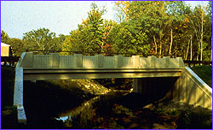
Arch bridges are one of the oldest types of bridges and have great natural strength. Instead of pushing down the weight on an arch bridge is carried outward along the curve. Modern arch bridges usually span between 200-800 feet.
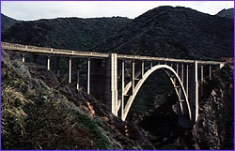
Cable-stayed bridges may look similar to suspension bridges but the two bridges support the load of the roadway very differently. In cable-stayed bridges, the cables are attached to a tower or multiple towers, which alone bear the weight load. Cable stay bridges are used for distances between 500 and 2,800 feet.
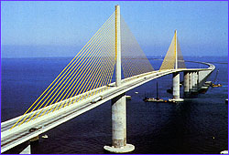

Suspension bridges span the greatest distances of 2,000 to 7,000 feet—far longer than any other kind of bridge. They also tend to be the most expensive to build. True to its name, a suspension bridge suspends the roadway from huge main cables, which extend from one end of the bridge to the other. These cables rest on top of high towers and are secured at each end by anchorages.
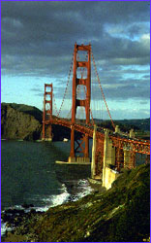
- Give students and parents directions to activity.
- Your mission is to design a bridge that spans the distance between the two desks.
- When you come up to collect your materials you will give me your team name.
- Your team will compete with all of the other teams to see which bridge could hold the most amount of weight.
- The team with the bridge that holds the most weight wins a prize.
- Your materials will be toothpicks and marshmallows.
- Here are several pictures to help you in designing your bridge.
- When you are finished, bring your bridge to the weigh station and we will see how strong your bridge is.

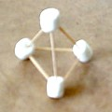
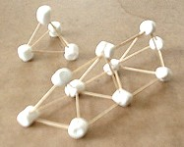
- Distribute materials, allow time for activity.

- Weigh bridges and find a winner.

